Cloud computing final exam

IMPLEMENTATION OF THE OWNCLOUD SERVICE

Nina Krstovic 2018230089 SDE

Introduction

OwnCloud is a suite of client-server software for creating and using a file hosting service, or in other words, a model of computer storage that stores data in logical pools, much like Dropbox or Google Drive. However, the primary difference is that ownCloud is free and open source, meaning that anyone can install and operate it on a private server, without charge.   
 OwnCloud also supports extensions that allow users to perform other activities such as online document editing, contact synchronization and many more, and can be accessed via the web or the applications (desktop, Android, IOS, Windows Mobile) offered by ownCloud itself.

Technology

In this implementation, the technology used is virtualization (VirtualBox). It allows an unmodified operating system with all of its installed software to run in a special environment (virtual machine), on top of the existing operating system. The virtual machine (guest) runs directly on the processor of the host (physical computer), but various techniques are employed to intercept operations that would interfere with it.

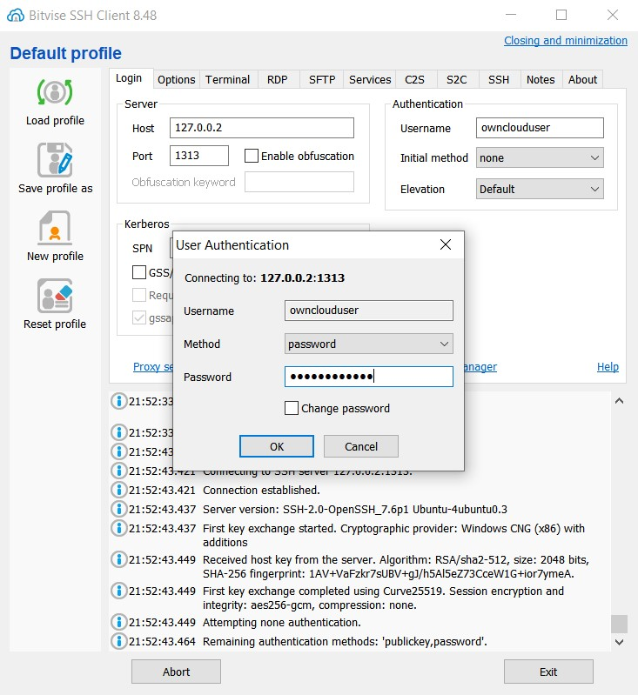

Implementation

The implementation is performed on the Linux UbuntuServer 18.04 LTS virtual machine.

Firstly we need to connect via the Bitvise SSH client or PuTTy by using the local loopback address and the designated port number specified in the forwarding rules (in this case: *127.0.0.2, port: 1313*).

Before implementing the ownCloud service we first have to install the basic infrastructure services that are necessary in order for it to function.

We do so by running the following commands:  
 ▪ sudo apt-get upgrade (downloads installation packages)  
 ▪ sudo apt-get update (updates the list of repositories)  
 ▪ sudo apt-get install apache2  
 Once apache2 is installed we need to configure the forwarding rules for it.

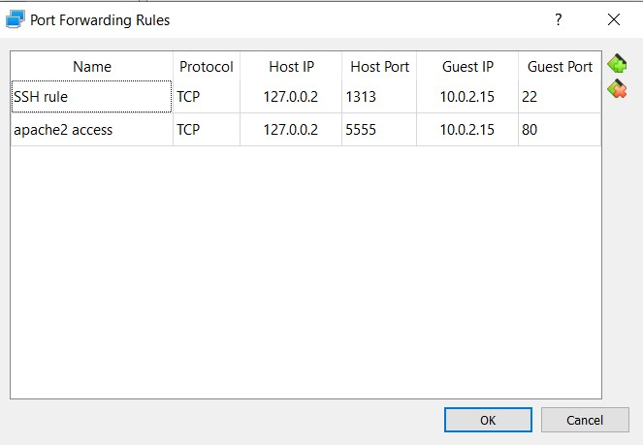

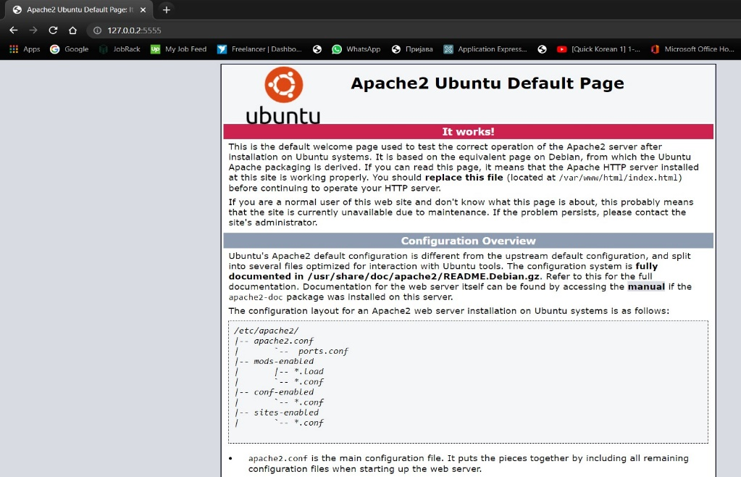Upon finishing the previous steps the connection between the web server and the host machine is tested via the browser by going to *127.0.0.2:5555*. If the connection is successful the following window will be shown:

When this is done, further apache adjustments are done:

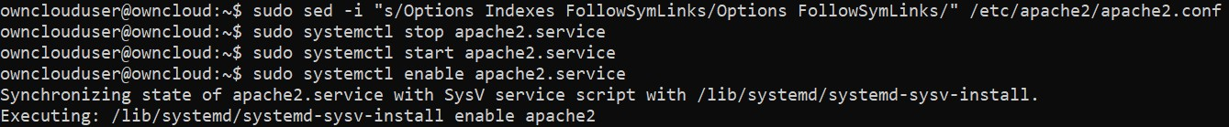

Now, the installation of the database client and database server is needed. In this case we use the MariaDB because it works best with ownCloud services.  
  
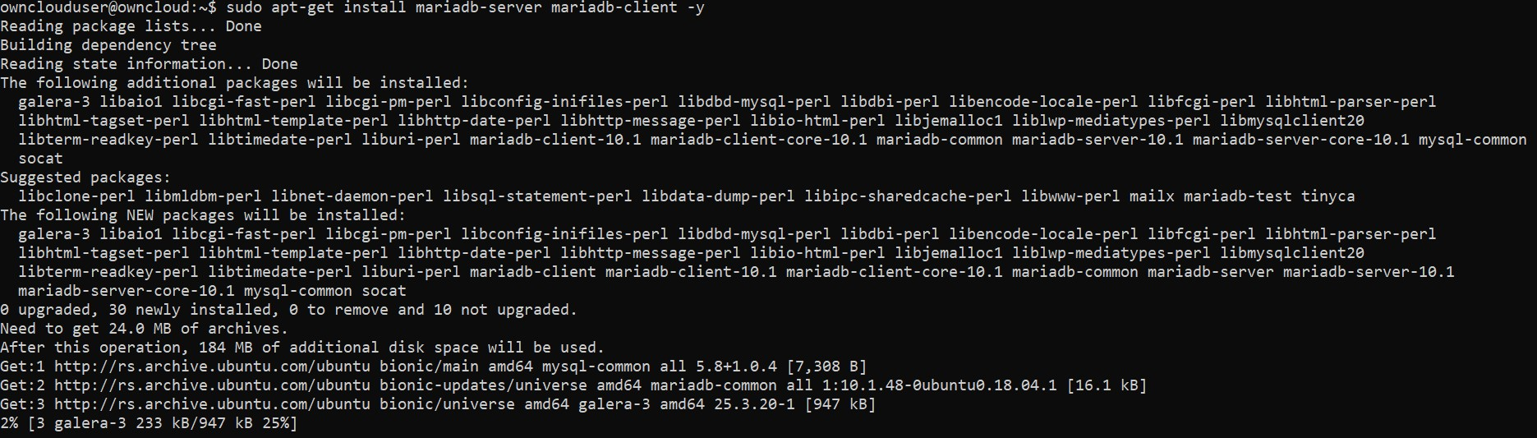



Once the DB is installed with need to connect to it and, since it by default doesn’t have a password, we need to set one by running the “**sudo** **mysql_secure_installation**” command.

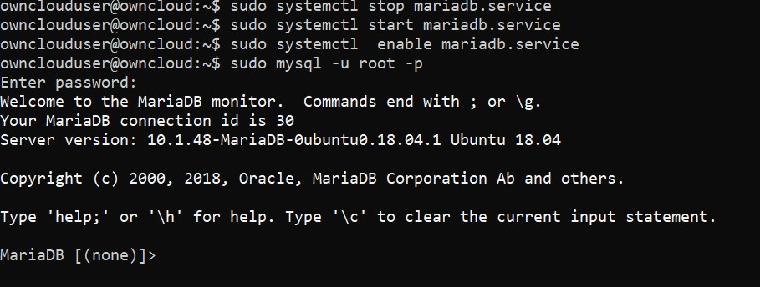

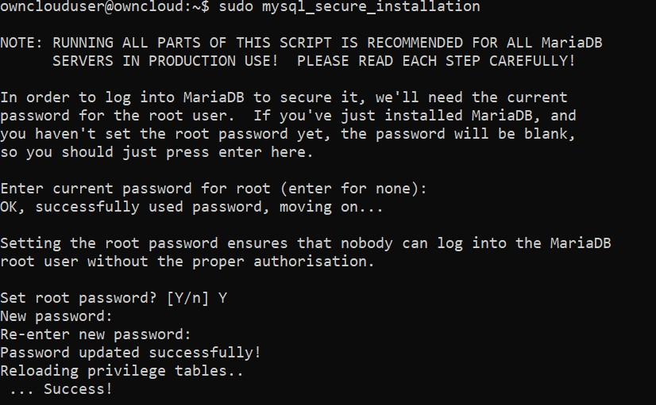

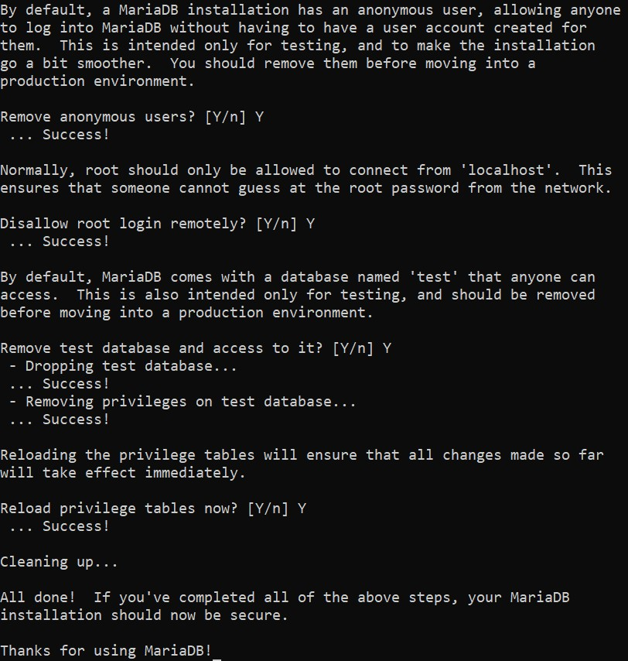Further setup is needed to remove the anonymous users, disallow root login remotely, remove test database and access to it and reload privilege tables.

Next step is to install additional php libraries.  
To do so we first install new software repositories and update:







Now, we can install said php libraries:

   


Once this process is done, we have to modify php.ini configuration file to control its behavior:



In this file we need to set:

▪ file_uploads = On   
 ▪ allow_url_fopen = On (open files by using the web browser)  
 ▪ memory_limit = 1000M (allowed memory size for all users)  
 ▪ display_errors = Off (we don’t want users to see the error)  
 ▪ date.timezone = Europe/Belgrade (the time zone of the server)

Now we save the changes in the file and run the “**sudo** **systemctl** **restart** **apache2**.**service**” to check if everything was done correctly.

When all this is done, we need to create an ownCloud DB user on MariaDB server:

1. Connect to the DB using the previously set password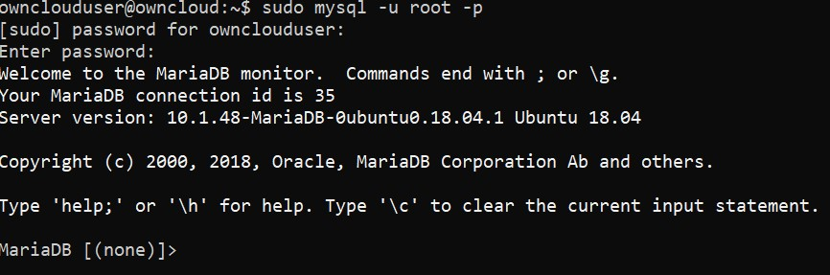
2. Create the user and the client, identify them by a certain password and give them all privileges for the ownCloud DB (@’localhost’)  
   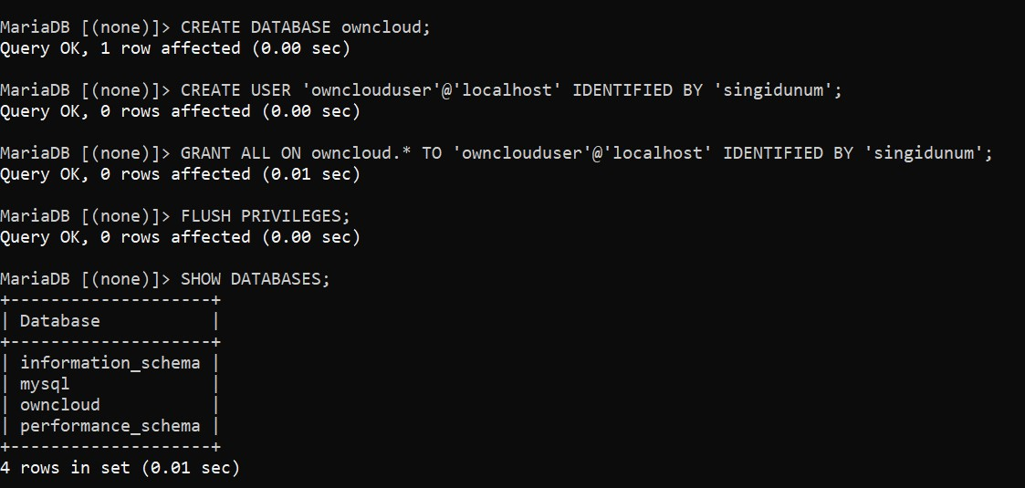

Now that the DB is set up we can download and unzip the ownCloud application (version 10.3.2) to install.  
This download process is done in the temporary file.

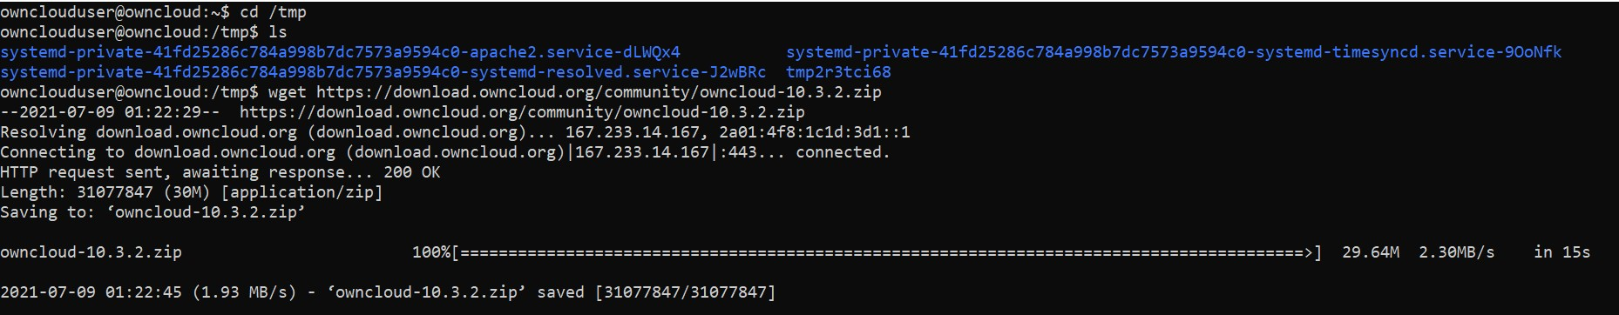

To unzip we use the command: **unzip owncloud-10.3.2.zip  
  
**

In order to start the installation process we need to move this folder to the root of the apache2 web server:



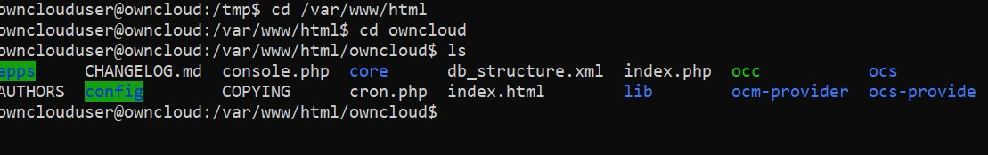

Now we need to change the ownership for the users (www-data) and assign permissions:



(the user as well as the group www-data will be the owner of this folder)



(user (owner) – 7 – right/write/execute, group – 5 – read/execute, admin – 5 – read/execute)

When this is done we need to configure the control for accessing the appache2 webserver, in other words: set who can access it.  
 ▪ run the command **sudo nano /etc/apache2/sites-available/owncloud.conf** to create the  
 configuration file  
 ▪ describe it in the following way:   
 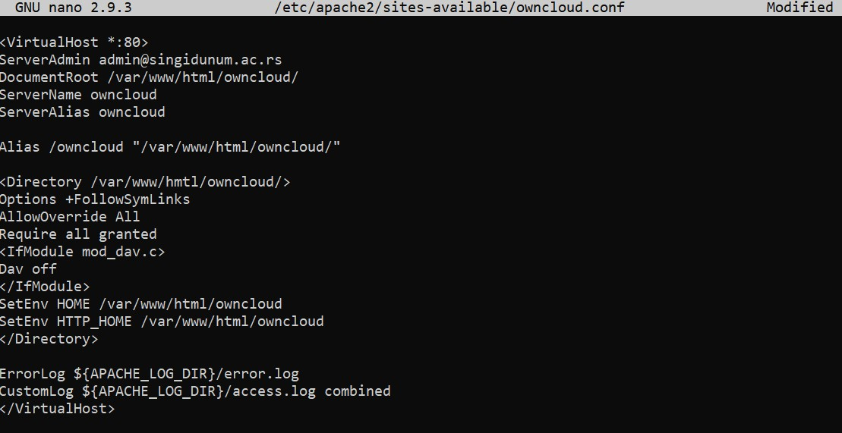

Adding this configuration file to the virtual site by executing:



(We have enabled this virtual site)

Now, we need to enable the read/write module (so the end users can override their own files),



The headers



As well as check if the environment, directory and mime extensions are enabled (if they are, we restart the apache2):

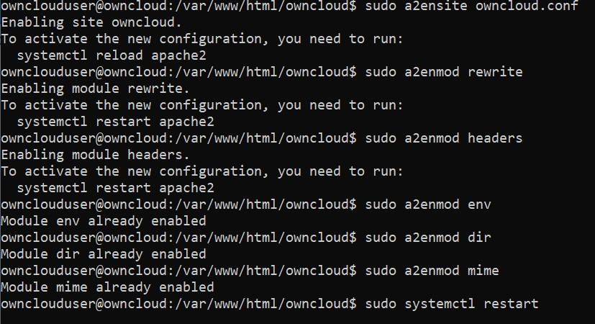



Now we can access the owncloud vie the browser by going to the *127.0.0.2:555/owncloud/index.php*

The following window should be given: We can then create the admin and the DB user accounts:  
  
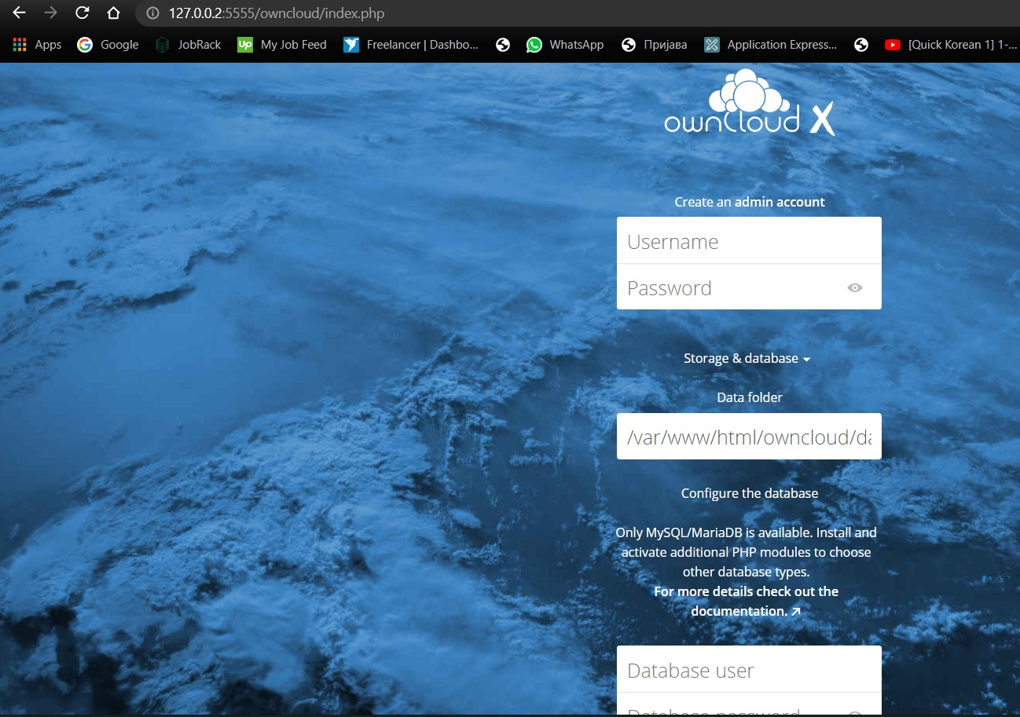 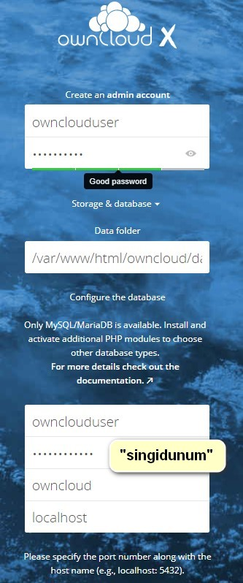

With this we have finished the implementation of the ownCloud service.

Conclusion

As stated in the introduction, the fact that the ownCloud is a free, open source platform is the biggest advantage of all, since it directly correlates with its availability and transparency. Moreover, ownCloud is also very secure, since it gives its users a lot of protection and flexibility regarding the way they operate the platform. Also, it tends to stay up-to-date with frequent updates and newer php implementations.  
 The biggest disadvantage on the other hand, is that it is not as easy to set up as other cloud services that offer same utilities (like Google Drive for example), it takes quite a bit of time, as well as knowledge to understand what should be done in each step. This is highly likely to be too demanding for an average person.  
 My opinion on the matter is the mixture of the previously mentioned advantages and disadvantages: the availability and transparency are excellent and do warrant further usage by the IT community, but given the fact that the same activities can be performed with less hassle through other platforms, I am not sure whether this platform, as is, is something that an “ordinary person” would want or know how to implement correctly.